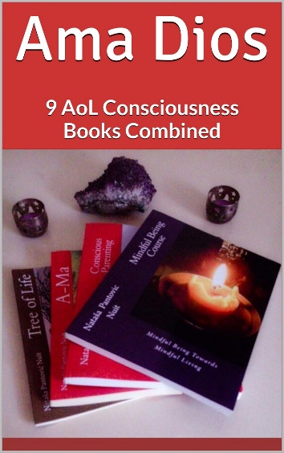
Ama Dios (9 AoL Consciousness Books Combined) by Nataša Pantović Launch 27.02.2019
During the last 5 years a team of spiritual researchers worked hard to complete and publish a series of 9 (nine) personal growth fiction & non-fiction books called: Alchemy of Love Mindfulness Training.
Applying Quantum Physics to manifestation of Consciousness researching Ancient Psychological aspects of Alchemy & Chinese, Greek, Hindu Philosophers, the compilation of 9 AoL books contains 2 fiction and 7 non-fiction exploring Symbols, Mysticism, Arts, Creativity, Consciousness & Beauty:
1. A-Ma by Nataša Pantović, Historical Fiction set in 17th Century China. A Mystical Journey of Portuguese, Chinese Consciousness Researchers, set in the Age of Enlightenment during the Dutch attack to Macao in 1622, the Reform of Chinese Calendar in 1630-s, with Father Adam Schall's appointment to the Chinese Board of Mathematicians during 1650-s, the witch hunt of a Shaman's African Goddess incarnated in China as Ama and her father Ottavio, a Portuguese Alchemist. Size: 244 pg, 6x9”, Paperback + e-Book
2. Art of 4 Elements: Exploring Alchemy through Poetry, Spiritual Four Elements Meditations, a Mystical Journey into Enlightenment through ancient mysteries and stories, by Nataša Pantović, Jason Lu, Christine Cutajar, Jeni Caruana. The 120 poems, written by Nuit, acted as an inspiration for the work of 3 artists. Size: 266 pg 8” x 10”, Paperback + e-Book
3. Mindful Eating with Delicious Raw Vegan Recipes, by Olivera Rosić .Designed with the best Alchemy of Love Mindful Eating Exercises and a collection of Delicious Raw Vegan Recipes. The Exercises help with over-eating, eating too often, eating too little, eating junk food, food allergies, etc. Size: 120 pg 6” x 9”, Paperback + e-Book
4. Chanting Mantas with Best Chords by Nuit. With more than 50 mantras from all around the world, their spiritual meanings, lyrics and chords, it explores: Hindu Sacred Mantras; Buddhist Mantras; Sufi Chants; New-Consciousness Mantras in English. Size: 120 pg 6” x 9” e-Book
5. Mindful Being towards Mindful Living Course by Nataša Pantović is a 12 Modules Personal Growth Course full of "Green Life-Style" exercises including self improvement and spiritual questionnaires, soul’s diary, behavior pattern modification, relationship contracts, and many other daily self-growth transformation tools on Nutrition, Core Beliefs, Emotional Intelligence, Mind Power, Creative Thinking, Joy and Love. Year: 2015, Size: 187 pg 8” x 10” Paperback + e-Book
6. Conscious Parenting: Mindful Living Course for Parents by Nataša Pantović and Ivana Milosavljević (Md Special Needs), a "Green-Lifestyle" Training designed for parents with plenty of Questionnaires and Family exercises. We explore the magic work with: Rhythm, Day-to-day Routine, Happy Family Structure, Cultivating Relationships, etc. We look into parenting goals, dreams, and creativity tools for kids. Size: 228 pg 8” x 10” Paperback + e-Book
7. Tree of Life with Spiritual Poetry. A Novel by Nataša Pantović Nuit is set in Findhorn, UK as a Journey into the Field of Dreams that In various religious interpretations, within myths, and as a mystical concept represents the inter-connection of all life on our beautiful planet. The story becomes a true adoption story venturing into Africa, Ethiopia, Kenia, within the magic of four elements, four directions, four stages of Life. Size: 264 pg 6" x 9” Paperback + e-Book
8. Conscious Creativity: Mindfulness Meditations by Nataša Pantović, Developing both Left and Right Brain could be essential for Creative Thinkers of our Future. To purify mind we start with the consciousness that energy follows thoughts and we use Quantum Physics Logic within Consciousness Research of Taoism following Yin and Yang Universe Manifestations to enter Creative Flow. Year: 2017 Size: 96 pages, 6" x 9" Paperback + e-Book
9. Spiritual Symbols with Their Meaning by Nataša Pantović. Our Holographic Universe resonates with the most amazing precision creating Realities of our Choice. Using the sound (Aum, Amin, Allah) resonance to mediate, today & in the past our artists use symbols to enter higher states of consciousness. From Neolithic wisdom of Ancient Temples' carvings of spirals, Pythagoras numbers, Leonardo da Vinci's paintings, ancient wisdom of magic, mysticism, occult travels to our worlds giving us conscious / subconscious gift from Greek Philosophers, Neolithic Temples Goddesses, Alchemy Size 152 pg 6" x 9" Paperback + e-Book
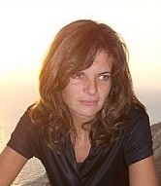
Nataša Pantović is a Serbian Maltese Management Consultant, BSc Economics, that lives and works in Malta. Books are published by Artof4Elements focusing on Personal Growth, Consciousness Research, Green Life-Style and Applied Psychology. Publisher’s website: www.artof4elements.com
Available through Amazon https://www.amazon.com/dp/B07NL6WBFR

